Assignment 2

Cell-DEVS Model of the Linear Response of a Two-Dimensional Truss Structure

Technical Report

Kin Wing Tsui (#100333520)

SYSC 5104 - Methodologies for Discrete-Event Modelling and Simulation

Fall 2007

1.0 Conceptual Model

Although common methods for analysing truss structures, such as finite element methods, have been successful in solving complex nonlinear problems, applying these analyses to optimizing truss design requires significantly more computational resources, involving an iterative process combining the modification of the design variables and the analysis for each design case. A traditional method for improving this iterative process is to use calculus of variations; however, the use of Cell-DEVS can provide a computationally more efficient numerical solution.

In this assignment a simple truss problem [1], shown in Figure 1, will be solved using Cell-DEVS. Each node – that is, the intersection of the truss members – will be considered as the centre of a cell, as shown in Figure 2.

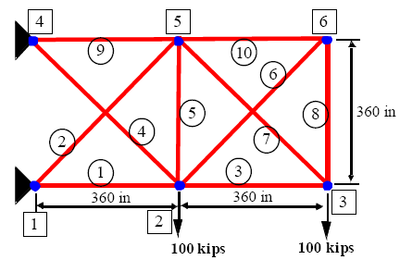 | 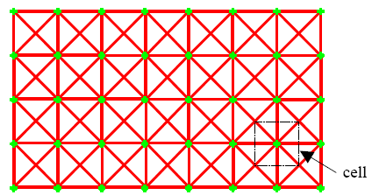
Figure 1 Truss structure problem to be solved; numbers in squares represent cell numbers | Figure 2 Definition of a cell in a truss

Structural analysis can be applied to each node. From equilibrium of forces,

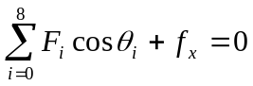 and 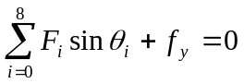 (1) and (2)

where F_{i} are the internal forces acting on the node by the neighbouring nodes through the truss member, θ_{i} are the orientation of the member (0° being along the x-axis, pointing east), and f_{x} and f_{y} are the externally applied forces on the node. The internal forces can be calculated from the strain of the member, ε_{i},

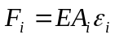 (3)

where E is the modulus of elasticity and A_{i} is the cross-sectional area of member i. The strain can be calculated from the nodal displacements of the cells connected by the member, i.e. the displacements of the current cell and of the i-th neighbouring cell,

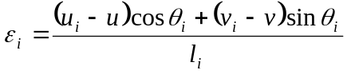 (4)
where l_{i} is the undeformed member length, u_{i} and v_{i} are the neighbouring cell’s horizontal and vertical displacements respectively, and u and v are the current cell’s displacements. Substituting equations (3) and (4) into equations (1) and (2), the current cell’s displacements can be expressed in terms of the neighbour’s displacements, given that all other parameters remain constant:

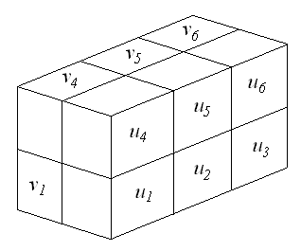
Finally, by solving for u and v, we obtain the rules

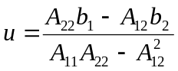 (5)
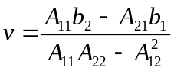 (6)

where
Figure 3 Cell space of the problem; each subscript is a truss node, with u as the horizontal displacement value of the node, and v as the vertical displacement
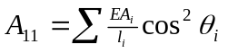
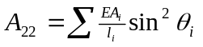
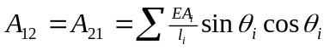
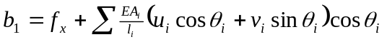
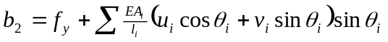

The Cell-DEVS model itself will be 3-dimensional: two dimensions for the 2-D truss structure, and the third for the two displacements u and v, as shown in Figure 3. This third dimension is, therefore, two cells long – one for each displacement value, in inches. The neighbourhood will be of the Moore type: the neighbours of a particular node are both u and v cells of all adjacent truss nodes {N, NE, E, SE, S, SW, W, NW, self}. For example, the u₃ cell has as inputs the u and v cell values of node 2, 3, 5 and 6.

The borders will not be wrapped to match the topology of the 2-D truss structure to be studied. Special rules apply to the border cells; depending on what members are absent, a rule is written such that A_{i} = 0. In our problem, all cells are border cells. Furthermore, where the truss is attached to a fixed point, the displacements of the fixed nodes will always be 0, both in their u and v cells.

The initial values for all cells are 0 (no displacements). The steady state values then become the final displacement values. The choice of delay should have no effect on the final values; a transport delay with a default 1 time unit delay time would be used.

2.0 Cell-DEVS Model

For the implementation of the truss structure model subjected to external loads in Cell-DEVS, a modification has to be made to the conceptual model to take into account the persistent external load. Two additional layers are added in the third dimension for the external forces in the horizontal and vertical directions. Therefore, the three dimensions for the full Cell-DEVS model for the 2-D truss structure are, in order,

- the vertical position of the truss node, x, starting at 0 at the top row of nodes and counting downward;
- the horizontal position of the truss node, y, starting at 0 at the left-most column of nodes and counting toward the right, and;
- a dimension of 4 layers, storing the specific values of
  - vertical displacements of each node, v, with positive up, on layer 0;
  - horizontal displacements of each node, u, with positive to the right, on layer 1;
  - vertical external forces at each node, f_{y}, with positive up, on layer 2, and;
  - horizontal external forces at each node, f_{x}, with positive to the right, on layer 3.

Figure 4 shows the cell-space of the model and the variable that each layer represents. The pictogram on the top shows the position of each node corresponding to each column of cells. The variables corresponding to each layer is shown on the right. The initial external forces values are set as shown in red and the pin-joint constraints are set constant as shown in blue.

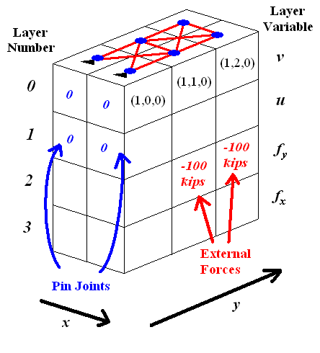
Figure 4 Revised cell space of the problem
The rules governing each cell in the v and u layers follow equations (5) and (6), where the summations are performed over the 8 immediate neighbours of the current node. Rules for cells at the border of the structure are similar to those of the cells at the centre, except that the summation does not include the terms that have undefined displacement values, which come from outside the cell-space.

To implement equations (5) and (6), each neighbour of the truss node must be numbered and defined. Figure 5 is a diagram that shows how each neighbour is numbered.

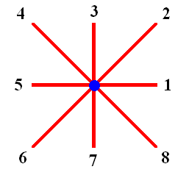
Figure 5 Neighbour numbers referred by the displacement equations

According to the diagram, the orientation of the members connecting the neighbouring nodes can be defined, as summarized in Table 1.

Table 1 Truss Member Orientation
Member | θ | cos²θ | sin²θ | sinθ cosθ
1 | 0° | 1 | 0 | 0
2 | 45° | 0.5 | 0.5 | 0.5
3 | 90° | 0 | 1 | 0
4 | 135° | 0.5 | 0.5 | -0.5
5 | 180° | 1 | 0 | 0
6 | 225° | 0.5 | 0.5 | 0.5
7 | 270° | 0 | 1 | 0
8 | 315° | 0.5 | 0.5 | -0.5

Using the values in Table 1 and expanding equations (5) and (6),

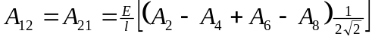

where A_{i} are the cross-sectional area of member i, and u_{i} and v_{i} are the horizontal and vertical displacements of the neighbour node i respectively, all of which are equal to 0 for non-existent nodes (cells that are outside of the cell-space). Note that when substituted into the displacement equations the E/l term is cancelled between the numerator and the denominator. In the CD++ implementation, each of the above 5 terms is placed in a macro.

Also, since the external forces are assumed to be constant and independent of truss deformation, the rules for the f_{y} and f_{x} planes are constant, “do-nothing” rules. The two external 100-kip loads are applied at cells (1,1,2) and (1,2,2), as previously shown in Figure 4. Finally, cells connected to a pin-joint are constraint, so their displacements are constantly 0 in both directions.

In order to capture the displacements of neighbouring truss nodes in the horizontal and vertical directions, and to continually obtain the external forces on the current node, the neighbourhood shape for the Cell-DEVS model is the 3-D Moore neighbourhood plus the second and third cells below the current cell. These two extra cells ensure that the external forces of the current cell are taken into account. Figure 6 illustrates this “tree” shaped neighbourhood. This neighbourhood is used in both the v and u layers.

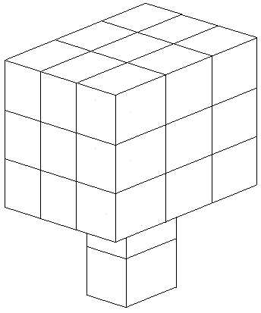
Figure 6 The “tree”-shaped neighbourhood; note the two extra cells below the Moore neighbourhood

3.0 Formal Specification

The formal specification of a Cell-DEVS model is given by

GCC = < Xlist, Ylist, I, X, Y, η, N, {r, c}, C, B, Z, select >

The truss structure Cell-DEVS model has the following formal specification.

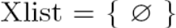

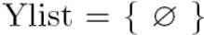

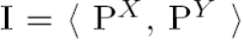

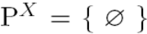

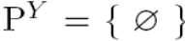

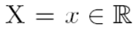

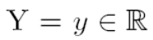

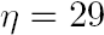

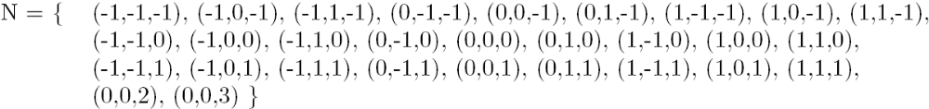

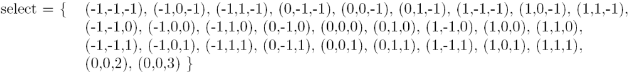

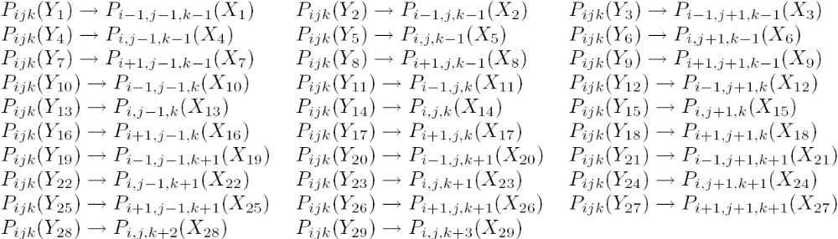
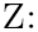

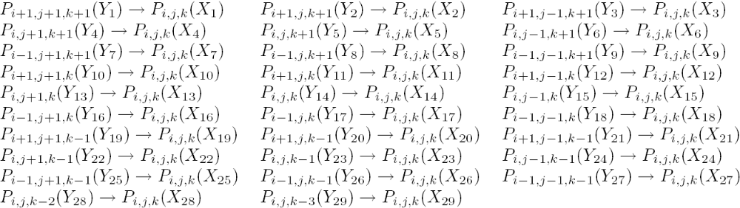

4.0 Execution Results

The truss structure Cell-DEVS model is built and run in the CD++ Builder and CD++ Modeler tools to obtain numerical and graphical representation of the results. The model converges to stead-state values, which form the solution of the truss structure problem. Two problems were analyzed: the original truss problem shown previously in Figure 1 and a Mitchell-type structure problem, with different constraints and applied forces.

4.1 Original Truss Problem

The Cell-DEVS model for the original truss problem converged to a three-decimal-place steady-state solution after 341 iterations. The displacement values for the nodes at which the forces are applied are found to be

{ u(1,1), v(1,1) } = {-18.021, -7.367} in
{ u(1,2), v(1,2) } = {-39.396, -9.522} in

These values are found to be the same as those obtained using a cellular automata model implemented in Mathematica [1]. The graphical representation of these results, generated using the CD++ Modeler Cell-DEVS animation tool, is shown in Figure 7. The left half represents the vertical displacements v, and the right half, the horizontal displacements u. The blue represents negative displacements (down or to the left), while red cells are positive displacements (up or to the right).

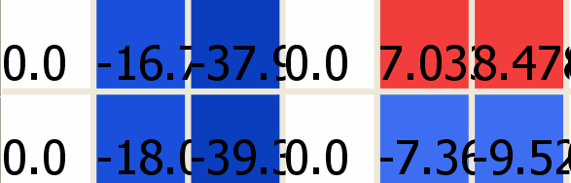
Figure 7 Truss analysis results

4.2 Mitchell-type Truss Problem

A Mitchell-type truss is a structure with two pin-joint constraints at the bottom-left and bottom-right corners and an external force applied at the mid point between the two joints. This type of truss is often encountered in design optimization problems, but in the context of this experiment the structure will be used as an illustration of the Cell-DEVS model.

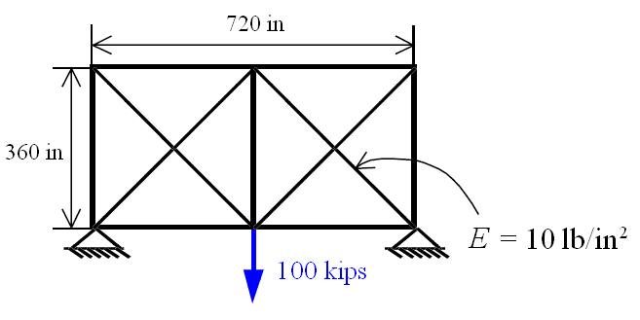
Figure 8 Mitchell-type truss structure problem

Figure 8 shows the geometry and forces of a Mitchell-type truss structure problem. Using the same material properties as in the original truss problem, this model converged to a three-decimal-place solution after 32 iterations. The vertical displacement value for the node at which the force is applied is found to be -4.346. The horizontal displacement is zero due to the symmetry of the problem. This result has been verified using finite element method performed in Microsoft Excel and MATLAB. Figure 9 shows the CD++ Modeler results. As with the original problem, the left half of the figure shows the vertical displacements v, and the right half are the horizontal displacements. Note the symmetry, particularly the horizontal positive and negative displacements the top corner nodes.

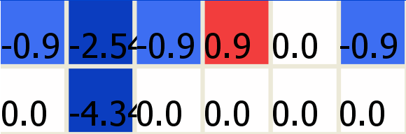
Figure 9 Mitchell-type truss analysis results

5.0 Non-linear Truss Response

It is possible, using cellular automata, to simulate the non-linear response of the truss structure to external forces. Using a derivation similar to the linear response equations, a set of non-linear equations can be derived for each nodal displacement value, by substituting the following equations into equations (1) to (4):

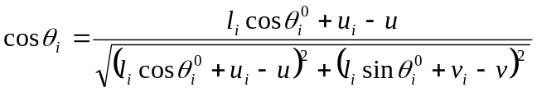

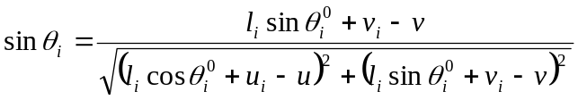

where 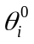 is the initial member angle at zero displacement. Note that the displacements u and v cannot be isolated as in the linear case – a multi-variable search algorithm is necessary, such as conjugate gradient or Levenberg-Marquardt methods, which are beyond the scope of this report. The Cell-DEVS implementation in terms of such a model would be similar to the one discussed in this report, substituting the current rules with the search algorithm.

6.0 References

[1] Gürdal Z. and Tatting, B., “Cellular automata for design of truss structures with linear and nonlinear response," Proceedings of the 41st AIAA/ASME/ASCE/AHS Structures, Structural Dynamics and Materials Conference, AIAA Paper 2000-1580, Atlanta, GA, 2000.

